Approved
Piano Movers in Hornsby: Expert Guide to Moving Your Instrument Safely 
Keywords:
- piano movers Hornsby
- piano transport
- upright piano movers
- heavy instrument moving
Meta Title: Piano Movers in Hornsby – Expert Guide to Moving Safely
Meta Description: Discover how piano movers in Hornsby ensure a safe, hassle-free relocation of your instrument with expert tips, proper equipment & professional care.
Permalink: https://www.cbdmovers.com.au/blog/piano-movers-in-hornsby-safe-moving-guide
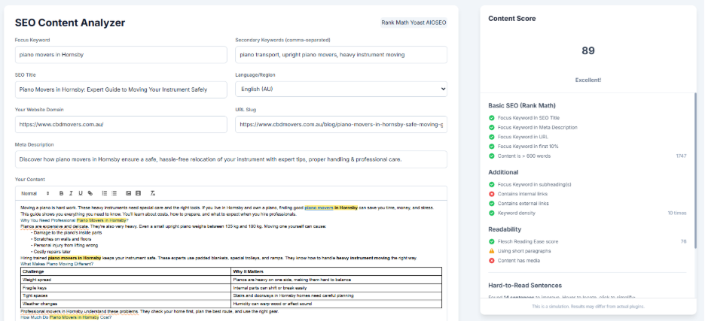

Moving a piano is hard work. These heavy instruments need special care and the right tools. If you live in Hornsby and own a piano, finding good piano movers in Hornsby can save you time, money, and stress.
This guide shows you everything you need to know. You'll learn about costs, how to prepare, and what to expect when you hire professionals.
Why You Need Professional Piano Movers in Hornsby?
Pianos are expensive and delicate. They're also very heavy. Even a small upright piano weighs between 135 kg and 180 kg. Moving one yourself can cause:
- Damage to the piano's inside parts
- Scratches on walls and floors
- Personal injury from lifting wrong
- Costly repairs later
Hiring trained piano movers in Hornsby keeps your instrument safe. These experts use padded blankets, special trolleys. They know how to handle heavy instrument moving the right way.
What Makes Piano Moving Different?
Challenge | Why It Matters
Weight spread | Pianos are heavy on one side, making them hard to balance
Fragile keys | Internal parts can shift or break easily
Tight spaces | Stairs and doorways in Hornsby homes need careful planning
Weather changes | Humidity can warp wood or affect sound
Professional movers in Hornsby understand these problems. They check your home first, plan the best route, and use the right gear.
How Much Do Piano Movers in Hornsby Cost?
The cost depends on a few things. Here's what you can expect based on local prices from removalists in Hornsby:
Piano Type | Estimated Cost | Time Required
Upright piano (local) | $250 – $400 | 1.5 – 2 hours
Upright piano (long distance) | $400 – $700 | 3 – 5 hours
Same building move | $150 – $250 | 1 hour
These prices include workers, equipment, insurance, and transport. Always ask for a written quote first.
What Changes the Price?
- Distance: Short moves in Hornsby cost less than long trips
- Stairs: Each flight adds $50 to $100
- Tight spaces: Narrow halls may need extra workers
- Piano age: Older pianos need more care
Many Hornsby families move during school holidays. Booking early helps you avoid busy times and higher prices.
What to Expect from Piano Movers in Hornsby?
When you hire professional removalists, you get more than just help. You get experts who know what they're doing. Here's what's included:
1. Home Check First
A good company visits your home to look at:
- Your piano type and size
- Doors, stairs, and paths
- Any tight corners or furniture
This helps them plan the safest way to move it.
2. Special Equipment
Professional movers bring:
- Piano dollies: Made just for piano weight and shape
- Tailgate lifts: For smooth loading onto trucks
- Straps and blankets: To protect and secure
- Safe trucks: With climate control for the trip
Read this to know what other tools make moving easier. The right equipment makes all the difference.
3. Trained Team
Upright piano movers know how to:
- Lift without hurting their backs
- Wrap pianos in thick padding
- Move through tight spaces carefully
- Work together without mistakes
In Hornsby, many movers have years of practice with older homes. These homes often have narrow stairs or low ceilings.
4. Insurance Protection
Good piano movers in Hornsby have insurance that covers:
- Damage to your piano
- Damage to your home
- Worker injuries on your property
Always ask to see proof before you book. Learn more about moving insurance essentials to protect your valuable instrument.
How to Prepare Your Piano for Moving Day?
Even with professionals, you can help make things easier. Follow these simple steps:
Before the Movers Come
- Close the keyboard lid and lock it
- Take off loose items like music books
- Clear the path from piano to door
- Measure doorways to check if it fits
- Take photos for insurance records
On Moving Day
- Stay nearby to answer questions
- Show them weak spots like cracks
- Keep pets away for safety
- Have a backup plan if doors are too small
Many Hornsby families also book an end of lease carpet cleaning on the same day. This makes moving out much simpler.
Common Mistakes When Moving Pianos in Hornsby
Avoid these errors to keep your move smooth:
Picking the Cheapest Option
Low prices often mean:
- No insurance coverage
- Workers with no training
- Poor quality tools
- Hidden extra fees
Always choose piano movers in Hornsby with good reviews and clear prices.
Waiting Too Long to Book
Busy moving season in Hornsby runs from December to February. Booking late can mean:
- Higher costs
- No available dates
- Rushed service
Try to book at least two weeks ahead.
Not Asking About Stairs
If you have stairs, ask about the cost first. Some companies charge per flight and some companies don’t move the piano from stairs.
Skipping the Tune-Up
Pianos shift a bit during moves, even with care. Book a tuner 2 to 3 weeks after moving. This lets the piano settle first.
Why Hornsby Families Choose Local Piano Movers?
Hornsby has many older homes, new apartments, and hilly streets. Local removalists know these challenges well:
- Steep driveways: Many homes sit on slopes
- Heritage houses: Older homes have narrow doors
- Traffic times: Locals know the best moving times
Data from the Hornsby Shire Council shows over 47,000 households in the area. Many are musical families. Local movers work faster because they know the streets.
What Families Say?
Reviews show that families care about:
- Being on time: Starting and finishing when promised
- Gentle handling: Treating pianos with respect
- Clear updates: Keeping families informed
Look for these points in Google Reviews when choosing a company.
How to Choose the Right Piano Movers in Hornsby?
Not all movers are the same. Use this list to find the best piano movers in Hornsby:
1. Check Their Papers
- Do they have a license?
- Do they have insurance?
- Do they focus on piano transport?
- How long have they worked in Hornsby?
2. Read What Others Say
Look for comments about:
- How they handle delicate items
- Being on time
- Fixing damage if it happens
3. Get Several Quotes
Call at least three companies. Compare:
- Starting price
- What's included
- Insurance details
- When they can come
4. Ask About Their Tools
Make sure they have:
- Special piano dollies
- Thick protective blankets
- Ramps or tailgate for trucks

5. Ask How They Work
A good company explains:
- How they check your home
- What path they'll take
- How they secure the piano
- When it will arrive
If you're leaving a rental, getting a move out cleaning quote helps you plan everything at once.
What Happens After the Move?
Once your piano reaches its new home, there's a bit more to do:
1. Let It Rest
Wait at least 48 hours before playing. This prevents stress on the wood and inside parts.
2. Book a Tuner
Temperature changes affect the sound. Get a piano tuner to fix it after the move.
3. Check for Problems
Look for:
- Scratches or dents outside
- Loose keys or pedals
- Different sound
If you see damage, call your piano movers in Hornsby right away.
4. Place It Right
Put your piano:
- Away from windows and sun
- Away from heaters or air vents
- On flat, stable ground
- Against an inside wall for better sound
Piano Moving Rules in Hornsby
When moving big items in Hornsby, you might need:
- Council permits: For trucks blocking streets
- Building rules: Apartments have moving time limits
- Floor protection: Using runners to protect floors
Check with the Hornsby Shire Council for rules in your area.
Rule | Details
Moving permits | Needed for some street parking
Building laws | Follow specific moving hours
Noise limits | Avoid early morning or late night
Professional piano movers in Hornsby know these rules. They handle permits for you if needed.
Extra Services from Piano Movers in Hornsby
Many piano movers also offer:
- Piano storage: Safe places to keep your piano
- Interstate moves: Professional interstate movers from Sydney can take it anywhere
- Furniture moving: Help moving your whole home
- Packing help: Expert packing of fragile items
Bundling services can save you time and money.
Final Thoughts: Trust the Experts
Moving a piano in Hornsby doesn't have to be hard. With good piano movers in Hornsby, your instrument arrives safely and on time.
Whether you're moving nearby or far away, professional heavy instrument moving gives you peace of mind. They do the hard work, handle tight spaces, and protect your piano.
Ready to move your piano? Contact CBD Movers today for a free quote. We've helped Hornsby families for years. We'll make your move smooth and stress-free.
Frequently Asked Questions
1. How much do piano movers in Hornsby charge?
Local moves cost $250 to $400 for upright pianos. Long-distance moves range from $400 to $700. Prices depend on stairs, distance, and how hard it is to access your piano.
2. Do I need to empty my piano before moving?
Yes. Remove all sheet music, books, and loose items from inside and on top. Lock the keyboard lid to protect the keys during transport. This prevents damage and makes the piano lighter and safer to move.
3. Can piano movers handle stairs in Hornsby homes?
Yes. Professional upright piano movers are trained to navigate stairs safely. They use special equipment like ramps and straps.
4. How long does it take to move a piano in Hornsby?
Most local moves take 1.5 to 2 hours. This includes wrapping, loading, transport, and unloading. Long-distance moves can take 3 to 5 hours or more. The time depends on distance and access to both homes.
5. Is my piano insured during the move?
Reputable piano movers in Hornsby carry goods-in-transit insurance. This covers accidental damage to your piano and your property. Always ask for proof of insurance before signing any contract. Good companies show this information upfront.
6. When should I tune my piano after moving?
Wait 2 to 3 weeks after the move. This lets your piano adjust to the new temperature and humidity. Then schedule a professional tuner. Even careful moves can affect the strings and sound quality slightly.
7. Can I piano transport myself to save money?
It's not recommended. Pianos weigh 135 kg or more and have delicate internal parts. Moving one yourself risks serious injury and costly damage. Professional piano movers in Hornsby have proper training, equipment, and insurance. The small cost is worth protecting your instrument and your health.

